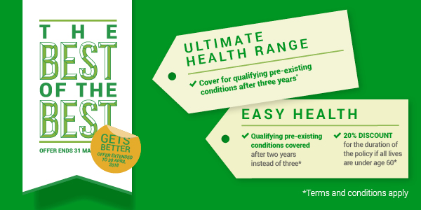

[Adviser letterhead and contact details]

[Date]

Dear [client name]

A healthy kick-start to 2018 with nib health insurance.

A lot can change in a year, so now’s a good time to review your needs and consider the kinds of personal insurance that you might need.

You can’t control everything life throws at you, but with health insurance, you can rest easy knowing you and your loved ones can access quality treatment when you need it most.

Buying insurance can be confusing, so I can help make it simple and recommend the best kind of cover for you.

While you’re thinking about it, I want to let you know about nib’s health insurance offer(s) available now. One offer provides cover for many pre-existing conditions after three years – a good option to consider if you’ve already had a particular health condition you’d like covered in the future. And the other offer is a permanent 20% discount on a different cover. These offers are available for a limited period and are subject to terms and conditions.

I’ll call you in the near future to make a time to meet and review your cover and to talk to you about these great offers.

All the best,

[Adviser letterhead and contact details]
[Date]
Dear [client name]
Have you ever wondered what it would be like waiting for treatment for a moderate to serious health condition? Until it has happened, many people don’t realise what an impact it can have on their ability to keep earning, to continue personal interests and to enjoy life and time with friends and family.
Health insurance is designed to take the uncertainty and delays out of getting treatment and to help get you back to normal as quickly as possible. It also ensures you are able to choose who, when and where you get treatment.
Many of my clients consider health insurance when we’re discussing their overall financial needs and concerns. It can be complex so my job is make it simple. I help people understand and prioritise their needs and use products that can be customised so my clients get good value for money.
I also have access to some special offers. For example, nib has recently made several health insurance offers available that I recommend clients consider. One offer provides cover for many pre-existing conditions after three years – a good option to consider if you’ve already had a particular health condition you’d like covered in the future. And the other offer is a permanent 20% discount on a different cover. These offers are available for a limited period and are subject to terms and conditions.

I’ll call you in the near future to make a time to meet. A half hour meeting is all it takes to identify whether or not I can assist you. Proceeding from there takes a bit more time, but it’s worth it.
All the best,

